Project 1 Analysis Report

Process to collect data:

For each different input file, and each algorithm, I selected the worst case runtime (the year with the most data entry, which is consequently the most recent year with data for each input file). I wrote these down in a table, and graphed the results.

Results:

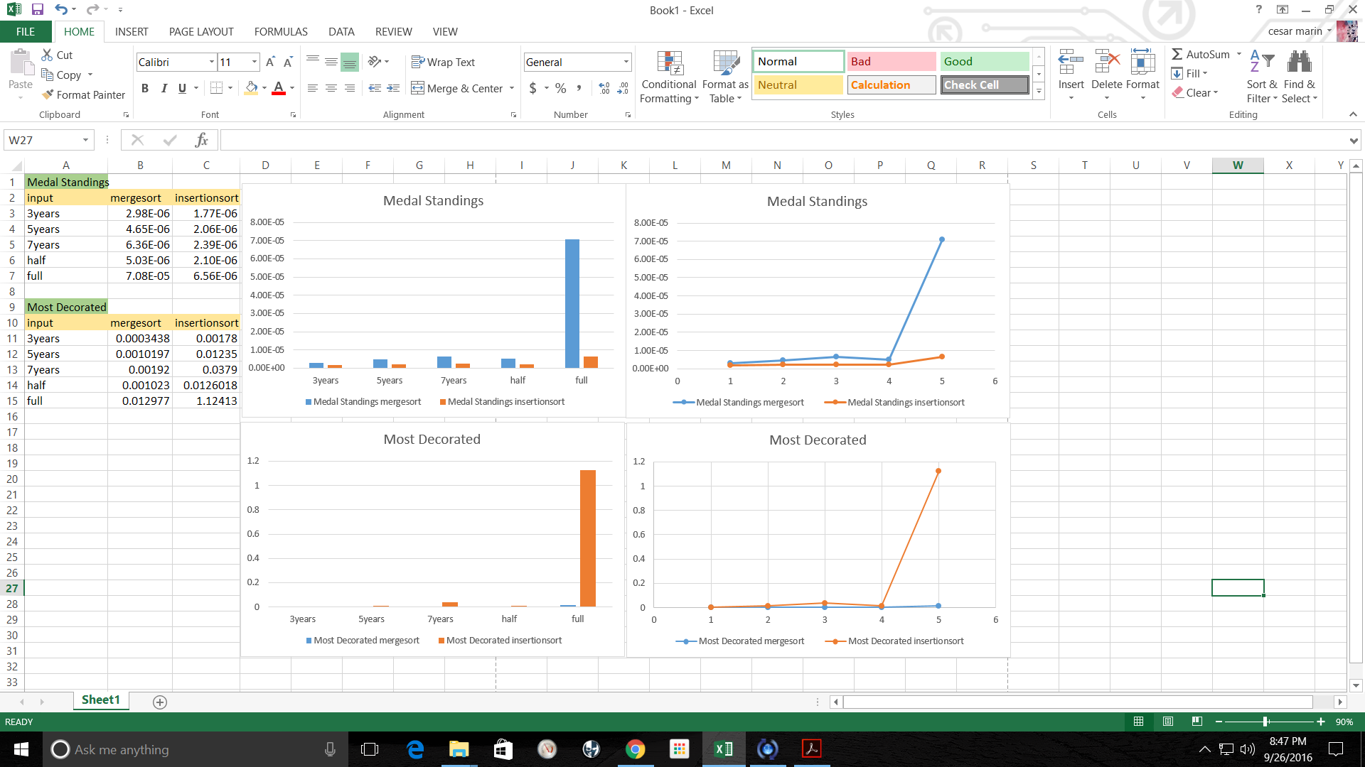

As we can see, insertion and merge sorts have the opposite runtime experience for Medal Standings and Most Decorated queries. Based on this, we can see how insertion sort is most useful for small data (in the case of medal standings, the data was separated into years, making it much smaller than the total data for all years) And merge sort is most useful for large data (in the case of medal standings, we had a much larger input, as this was not separated by years).

For a closer look at the data and graphs, look at the pdf file in this directory.